Our Vision

To glorify God by planting a new church that will uplift minds, hearts and spirits.

We Seek:

- To uplift young professionals through the word of God. Many young people born between 1980 – 2000 (referred to as millennials) have grown up without being deeply connected to a church family. Some between the ages of 24-30 have attended college as they were instructed and are not under a mountain of student load debt. Those some young adults are living in a world where they lack job security and a stable home environment. As a result of the pressures of life many of our best and brightest are breaking down because of the difficulties they face. We seek to lift them by surrounding them with a community of faith that will lift them intellectually, emotionally and spiritually.
- While it is true that the millennials have inheriated a vastly different world from previous generations, it is also true that the millennials have access to more information and resources than any previous generation. Uplift is to be a place that develops servant-leaders that come to church to be uplifted but go into the world to be uplifting. The millennials have more information and resources as a result can bring more solutions to problems plaguing our world. We seek to be change agents that bring solutions to our community.

Why Plant a new church in the Baltimore-Washington Area?

The Baltimore-Washington Area is home to over 9 million people. With a growing metropolitan population, the Baltimore-Washington Area is a metropolis of diverse cultures and communities. With many of the nations leading employers and government agencies headquartered in the Baltimore-Washington Area, this area is a leader within an increasingly global economy. With such diversity comes the strategic opportunity for the gospel to impact not only the Baltimore-Washington Area, but also the innumerable cultural and sociological systems and networks that exists throughout the metropolitan area. Laurel, MD, a tri-county city located in the Baltimore-Washington Area’s expanding region, provides an excellent and strategic setting for addressing the marginalization of the gospel within this growing community.

Why Laurel, MD?

Laurel is a city that spans three of Maryland’s largest counties and it is located between Baltimore and Washington, DC. Laurel is a city with a growing number of young professionals moving to the area for school and government jobs. Downtown Laurel, is currently making major renovations as a result of the population growth. The emerging demographics of the area point to a post-Christian culture with little or no Christian memory, the area has very few churches to reach those moving to the area. Laurel provides an excellent setting for church planting.

Community Assessment / Profile

The population of Maryland is projected to increase by 12% over the next 10 years and Laurel is no exception to the extraordinary growth. For a full demographic report, please visit: http://www.mdp.state.md.us/msdc/S3_Projection.shtml

The reason Laurel is experiencing this phenomenal growth is directly related to Base Realignment and Closure (BRAC). BRAC is expected to relocate 5,400 jobs to Fort George Meade from cites outside of central Maryland. It is projected that these BRAC job will result in 16,061 new jobs by 2015. Many of the jobs that will be relocated are now located in Northern Virginia.

As observed, the city is experiencing an influx of young professional suburbanites.

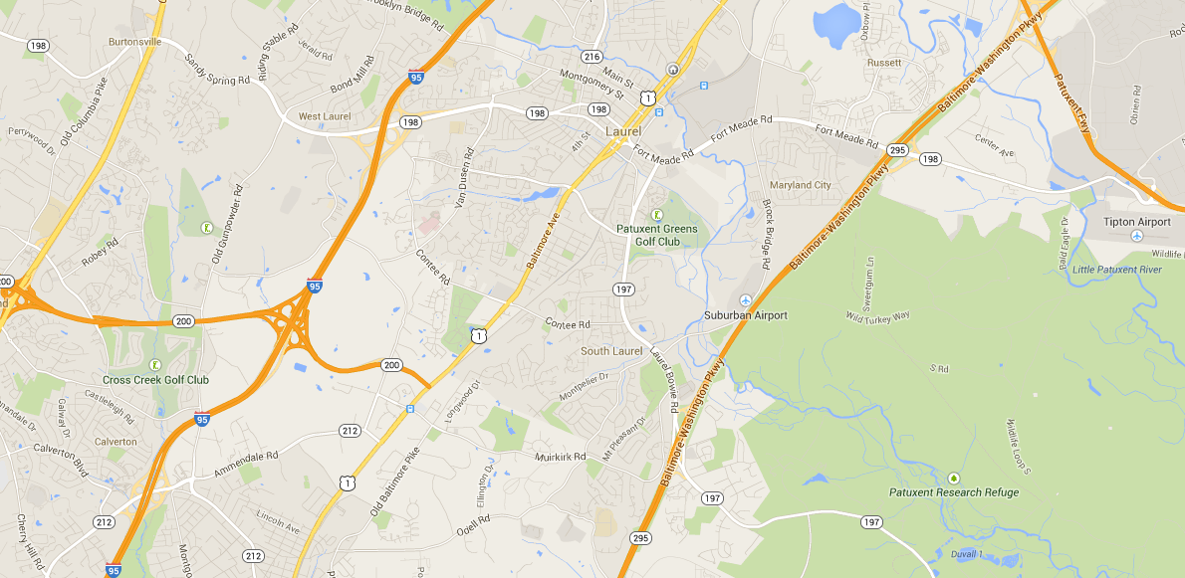

Demographics

Given that Laurel is spread across three counties the demographic profile will have to be inclusive of all three counties.

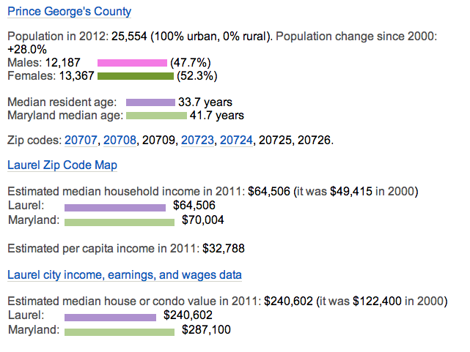
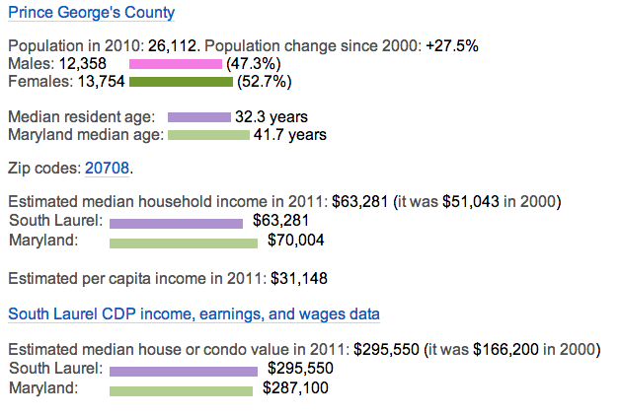
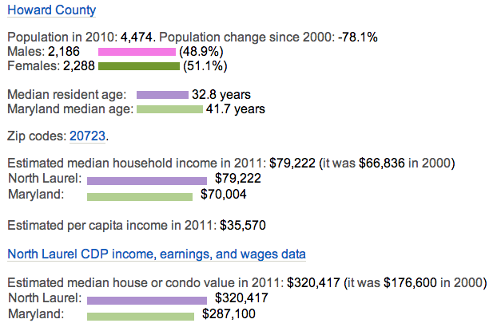
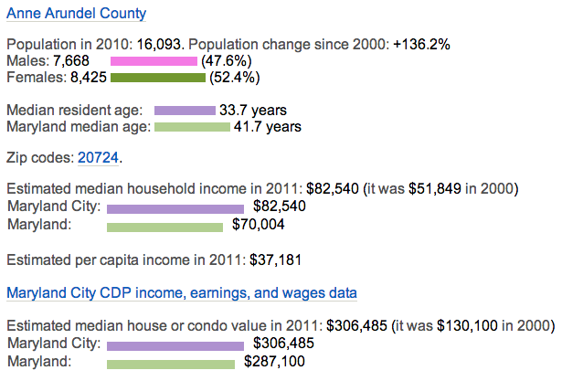

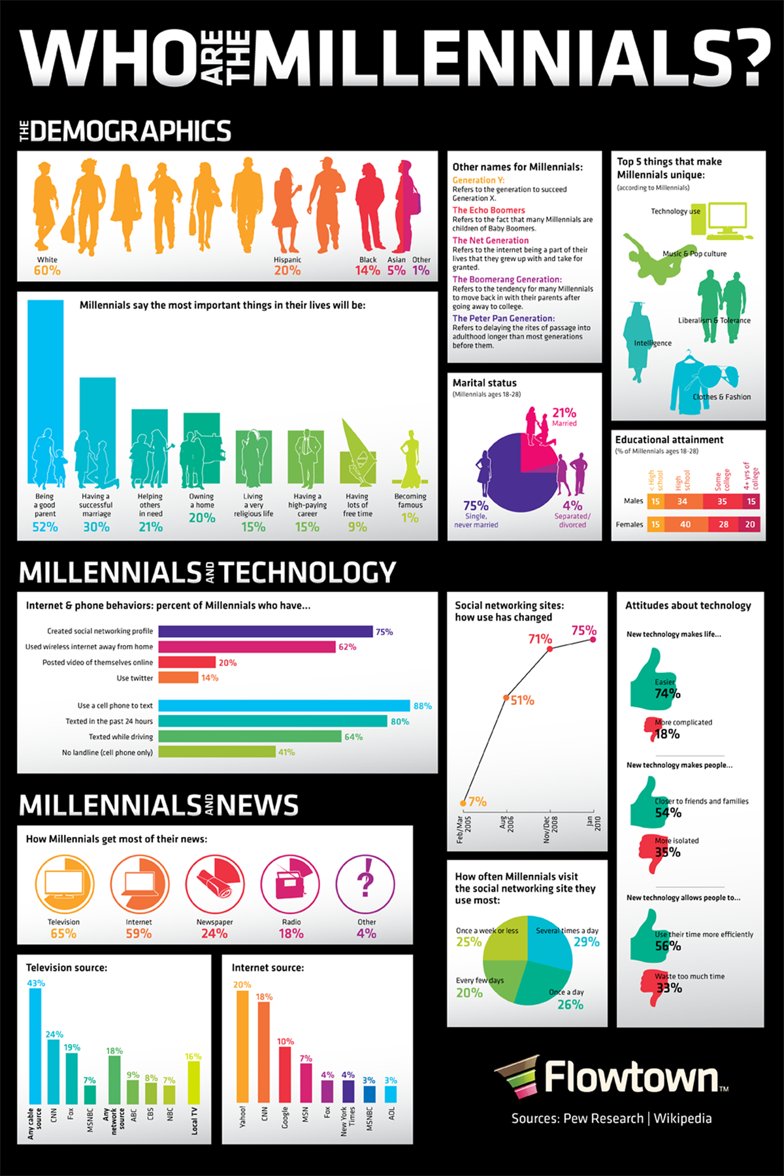
Partnership

Prayer
We will be asking individual partners and partnering churches to make an extraordinary commitment to pray for the success of this new church. Monthly updates/prayer letters will be distributed via email. Periodic prayer concerns will also be communicated via email.
- Individual Prayer. We’ll be asking each individual partner to pray for the success of Uplift Church each day. We’ll be asking each partnering church to appoint a primary prayer contact to recruit prayer warriors to community prayer requests.
- Corporate Prayer. We’ll ask each partnering church to include updates and prayer request from our church in it’s regular prayer bulletins and to pray for us during its regular prayer meetings
- Prayer and Fasting. During critical phases of our church’s development, we’ll ask individual partners and partnering churches to join us corporately in seasons of prayer and fasting. We believe that these seasons will be necessary to see genuine spiritual breakthroughs. During these times, we’ll want to be in close communication with our partners, both making known our challenges and needs and in reporting the awesome things that God is doing.

Mission Opportunities
Come be a part of exciting opportunities to reach out to the community of Laurel. There are various ways you or your church can contribute. Prayerfully consider which way God wants you to help us impact the community with the love of Jesus Christ.
- Servant Evangelism: Come and serve at an event in Laurel and help us show the love of Christ by serving our neighbors.
- Door-to-door surveying: Knock on doors and leave information about Uplift Church.
- Preview Services: Volunteer on Sunday morning and come staff a “Preview Service” so the Uplift Church staff can interact with guests.

Financial Partnership

Why we need your financial support…

As a new initiative, the Uplift Church leadership team is responsible for cultivating a team of ministry partners who will commit to financially and prayerfully support the church during our initial stages.

Would you consider investing in the planting of Uplift Church for a period of one year by contributing a monthly amount $100, $250, $500 or some other amount as we seek to make disciples within the Laurel area? Or perhaps you or your church would be willing to $1000 per month for one year as a mission project.

Partnering with Uplift Church

We invite you to become a partner in fulfilling our Mission to reach the community of Laurel. Your support makes it possible to serve the Lord and fulfill the Vision He has giving for Uplift Church. Please mail your contributions to Uplift Church at the address below. You may also donate online at www.upliftmd.com/donate .

CONTACT US
Uplift Church
P.0. Box 928
Laurel, MD. 20707
240-324-8277
www.upliftmd.com

The strategy for Uplift Church is to “launch BIG”. This will enable us to have a healthy church start and to grow from our first service. In order to “launch BIG” as per our strategy, Uplift Church needs the appropriate equipment and staff. Below is a breakdown of our budget.

2014 Budget

Nursery: | Diapers, wipes, changing station, toys | $1000
Children: | Supplies, toys, curriculum, videos, books | $1000
Visitors: | Follow-up material, visitors reception, contact cards | $1,500
Outreach: | Service projects in the city | $2,500
Marketing: | Website, direct mailers, signage, | $14,000
Equipment | Video production, sound and lighting | $8,000
Facility: | Rental | $12,000
 | TOTAL | $40,000

THE COMMITMENT

Individual Partnership

We invite you to join us as a financial partner in this effort to plant a new church in Laurel, Maryland through a monthly or one time investment.

- $50
- $100
- $250
- $500
- $_____ other
- One time gift monthly gift

Church Partnership

Our church would like to join you in this church planting effort through a significant investment of:

- $1000
- $________ other
- One time gift monthly gift

Name: _________________________________________________
Church Name: _________________________________________________
Telephone: _________________________________________________
City, State, Zip: _______________________________________________________________________
Email Address: _________________________________________________

Signature: _________________________________________________

To help us in our effort to maintain accurate records, please include this form with your initial contribution. Please feel free to copy this form for your records.

Please make your checks payable to Uplift Church and send to:

Uplift Church
P.O. Box 928
Laurel, MD. 20707

Each time you send your tax deductible contribution, we will mail you a remittance form and a self addressed envelope for your next contribution.

